Electric Vehicle Charging Station:
Project Plan

Group #: May 13-22A
Client: Paragon
Advisor: Dr. Bigelow

Members: Matthew Stobb
Brandon Umscheid
Derek Schmitz
Hamzah Abeer
Aziz Almarzouqi
Nick Riesberg
2012

1/1/2012

Table of Contents

Executive Summary: 3
Project Objectives: 3
Division of Labor: 3
Design Concept: 3
Physical Concept: 4
System Block Diagram: 5
System Description: 5
User Interface: 6
System Operation Environment: 6
Functional Requirements: 6
Non-Functional Requirements: 7
Project Deliverables: 7
Risks Associated with Charging Station: 8
Directory of Acronyms: 9

Executive Summary:
The purpose of this project is to introduce senior level students to the system design process through the planning, design, and construction of a vehicle charging station. The outcome of this project is to provide a working charging station capable of meeting the general parameters that are defined by a client Paragon.

Project Objectives:
- The first objective is to design a system capable of charging batteries that are lead acid or lithium ion, at a variety of capacity levels.
- The second objective is to design a microcontroller that can transmit the charging status of the battery to a remote user interface.
- The third objective is to be able to sustain a battery life of 3-5 years.
- The fourth objective is for the charging system to be portable, or for two systems to be constructed consisting of one portable system and one permanent charging station.

Division of Labor:
The division of labor of group designing the Charging Station is as follows:
- Matt Stobb is the group leader and handles all group coordination and project interfacing with the go kart group leader. He will be responsible for safety protocols and electrical standards. He will oversee and assist in all aspects of the recharging station and microcontroller.
- Brandon Umscheid, Derek Schmitz, and Nick Riesberg will have the responsibility of designing the recharging circuit. This includes design schematic, design of charging protection system, testing the design, and physical construction of the charging station.
- Hamzah Abeer and Aziz Almarzouqi will have the responsibility of designing the microcontroller and the user interface. This includes programming the microcontroller, building the interface, and installing and testing the remote user interface device.

Design Concept:
The system needs to be designed to meet all three functional objectives to meet the client’s needs. The overall system design should be capable of being portable or two systems should be used as a packaged product. This ensures the customer’s needs are satisfied and they have convenient options for usability.

Physical Concept:
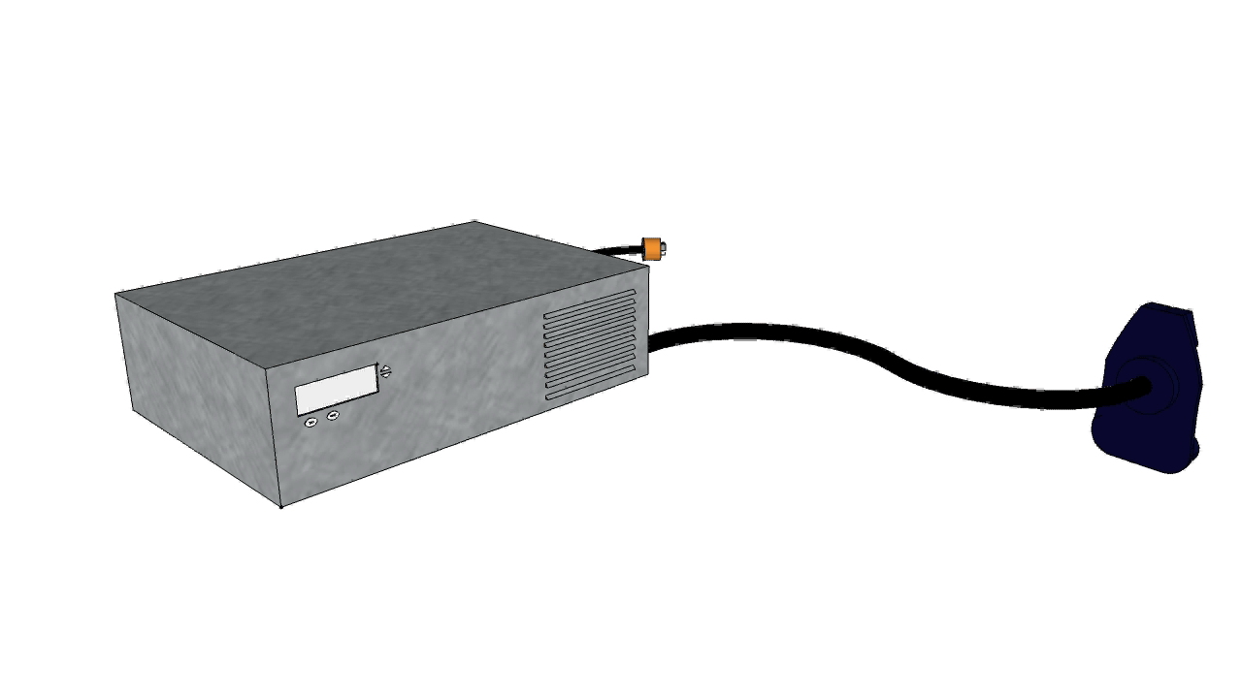
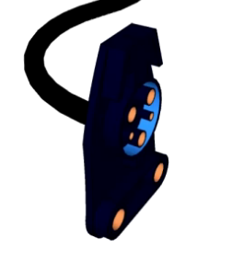

System Block Diagram:

System Description:
The charging station will be powered by a residential 120VAC source that will feed the general charging system and supply power to a microcontroller responsible for digitally controlling the overall system. The general system supply will feed into rectifier that will convert the VAC source to a VDC supply to feed the charging system. A buck converter or transformer will then be used to step up the voltage levels that are appropriate for the battery type being charged. The battery type will be selected using the user interface located on the charging station itself. The battery type (Lead Acid or Lithium Ion) will be selected as will the battery capacity setting desired. The charging system will be supplied with the appropriate settings and will then feed into the battery, while being managed and monitored by the battery protection system. The battery protection system is responsible for monitoring current, voltage, and thermal levels associated with the charging state of the battery to ensure that it is not overloaded and is able to charge safely. The micro controller will read this data from the protection system and will relay the SOC status. The protection system will monitor the pertinent information from the system and will shut down the system if it reaches dangerous levels of operation that will be predetermined based on the design.
The physical user interface and the remote user interface (RUI) will utilize the microcontroller to control system operations and to transmit and receive SOC data. The physical user interface will be located on the charging system itself and will be responsible for the selection of the battery type providing the options of Lead Acid and Lithium Ion. To select the battery type, the user pushes the button corresponding to the directive of the physical interface battery descriptions. There will be other buttons on the interface that the user will select for the desired battery capacity. Thus the user must be conscious of what type of battery that they are charging as well as its capacity and or limitations.

User Interface:
The RUI is responsible for allowing the user to view the charging and state of charge data from a remote location. The microcontroller used in the system will transmit data via Bluetooth technologies to any computer that is compatible with receiving Bluetooth data. The data may be viewed on the computer using the graphic user interface GUI that will be created to ensure convenient usability. Thus the client or user may view the charging system data remotely within a limited range away from the physical charging station itself. This is convenient for any residential customer that would want to view the data in their home if for example the charging system is located in their garage. Another component to the RUI is a key FOB that digitally displays the SOC data within a specified range of the Bluetooth specification.

System Operation Environment:
Marketed Operation Environments:

There will be as many as two charging systems being created, being the portable and stationary systems. Thus, there are two possible operation environments for this product to be marketed. The portable system will be operating in a variety of conditions, however, for the client Paragon the system will operate when mounted on the electric vehicle in which the system is being designed. This will be a moving environment so the system will need to be secured to the vehicle so that it may operate in safe conditions and it will need to be capable of safe operations outside the vehicle as well. The system must be contained within a small protective container that does not add very much weight to the vehicle itself. It must be able to withstand continuous use and operate within the vehicle itself. The stationary system must meet all the same requirements as the mobile system, however it will not be constrained as much by size. The system will need to be mounted or stored conveniently for customer use and each must be properly ventilated per design specification.

System Testing Environment:

There will only one environment for testing this product. This system is currently being designed for lab use and will later be used for the environments stated in previous section.

Functional Requirements:
- The target range of battery capacities include: 12, 24, 36, and 48 Volts. These capacities are the most commonly used for small electric vehicles. The batteries must have the ability to be charged quickly and reliably. The total charge time should be less than 8 hours at minimum.
- The Remote User interface RUI will include a portable device capable of showing the user the battery’s state of charge (SOC). This interface will digitally show the SOC on the physical charging in addition to having Bluetooth user capabilities allowing viewing SOC from a home computer.
- The charging station must be able to sustain a battery life of 3-5 years.
- The system must be designed to meet current engineering standards pertaining to this project.

Non-Functional Requirements:
- The system should be reliable and safe for customer use.
- The protection system should be able to terminate the charging process under conditions of fault or misuse.
- The system should be user friendly and easily directed with proper use of the physical control interface.
- The cost of the system must be reasonably priced and it should be produced with a budget near $500.
- The total size and weight of the portable system should be kept to a minimum to ensure vehicle safety and proper usability.
- The stationary system must be small enough for easy storage or mounting per customer preference.

Planning and Design Schedule:
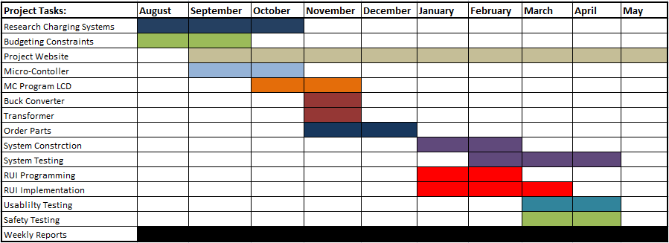

Project Deliverables:

Multiple Battery Charging System:
- The charging system will be capable of charging one battery at a time and will be capable of charging two battery types at multiple capacities. The system will be capable of utilizing a residential source of 120VAC with the capability of stepping the voltage down to 48 volts to meet the needs of multiple battery capacities.
Battery Protection and Management System:
- The charging of the desired battery will be protected and monitored by a system that will prevent over-current, over-voltage, general overcharge, thermal overload, and other fault conditions. The system will be implemented through hardware communicating with a microcontroller for digital and precise control to ensure safe product use.
Remote User Interface (RUI):
- The RUI will be tested and fully functional to ensure a reliable product and to ensure customer satisfaction. The user interface will be usability tested and easy to manipulate.

System Testing and Results:
- The overall system and its components will be thoroughly tested to ensure safe operating conditions. The tests will reveal that all tasks were accomplished and the functional and non-functional requirements have been met. The system will be tested to the satisfaction of the client and the product will be ready for use.

Risks Associated with Charging Station:

Project Hazards: | Hazard Description: | Hazard Solution:
Electrical Burns | Electrical burns are possible when working with higher voltages. Voltage cannot penetrate the skin, however, can cause serious burns. | When handling components and equipment, avoid contact with exposed high voltage wires. Do not handle when system is active.
Electrical Shock | The charging system source uses 120VAC and the system is built to operate 60A. Shock is a possible risk associated with charging system. | Avoid contact when system is active. Do not handle when exposed to other wires, frayed wires, or potentially dangerous environment.
High Current System | The system is designed for 60A of Current | Run functionality simulations starting with lower voltages.
Sensory Failure | Over-voltage, Under-voltage, and Thermal Overload may cause system damage or personal injury | Design Protection System to operate in robust scenarios. Perform robust testing to ensure safety of user and system
Micro-controller Damage | The Micro-controller governs the function of the system, if damaged, the system will not operate properly | Automatic shutoff protocol will be designed to turn the system off in situations where system damage may occur.
System Weight | The system should be lightweight so the EV balance cannot be disrupted. | The components and product casing will be made of lightweight material that is safe.
Electrical Fire | Electrical fires are possible when working with electricity. | Use fire extinguisher type C for electrical fires.
Cost | System design should keep cost minimal | Components will be selected to meet system constraints at minimal cost.

Directory of Acronyms:

SOC State of Charge
RUI Remote User Interface
VAC Alternating Current Voltage
VDC Direct Current Voltage
GUI Graphic User Interface
FOB Key chain indicator of charge
NEC National Electric Code
SAE Society of Automotive Engineers
IEEE Institute of Electrical an d Electronic Engineers

